**Summary of Studies: Embryo versus Sham Control Mice & Sham Control versus TAC Mice**

**Introduction**

In this part of the study samples were taken from study GSE58455. Treatments of embryonic mice hearts and Sham control mice were compared to one another, as well as Sham control mice and Transverse Aortic Constriction (TAC) mice. The objective was to observe any differentially expressed genes from a list of genes of interest (Figures 3&4). Samples were put into a comparison program for analysis that yielded results shown in (Figures 1&2) below are an example of expression results gathered.

Below are charts outlining expression of WWP1 throughout development. In both experiments transcript ENSMUST00000035982 (minus exons 6&7) was differentially expressed with an increase in Embryo versus Sham and a decrease in Embryo versus TAC. Transcripts ENSMUST00000108246 (full length) and ENMUSTTV074090 (minus exon 14) and ENSMUSTTV074090 (minus exon 9) were not differentially expressed in the analysis.

Figure 1 [WWP1 Expression levels in Sham Versus TAC]

Figure 2 [WWP1 Expression Levels Embryo versus Sham]

**Methods**

Samples were downloaded from the study GSE58455 from NCBI. Datasets were processed through a Next Generation Sequencing Workflow and analyzed to observe differentially expressed genes (DEGs).

**GSE58455 Results Embryo versus Sham**

Positive controls NPPA and ACTB are differentially expressed with higher expression levels displayed in the embryo sample. However NPPB is differentially expressed with higher expression in the Sham mouse, this matches the fold variance in the literature. Myh7 and SLC2A1 (GLUT1) were not differentially expressed in the sample comparison, so there is no way to see if there was an inverse expression of SLC2A1 (GLUT1) with SLC2A4 (GLUT4).

WWP1 in this experiment only had one transcript differentially expressed (ENSMUST00000035982) mentioned in the introduction.

**GSE58455 Results Sham versus TAC**

All positive controls (ACTB, NPPA, and NPPB) correlate with the literature, and exhibit an increase in expression in the TAC samples. Again SLC2A1 (GLUT1) was not differentially expressed so there is no way to show an inverse relationship with SLC2A4 (GLUT4) expression.

WWP1 in this experiment only had one transcript differentially expressed (ENSMUST00000035982) also mentioned in the introduction.

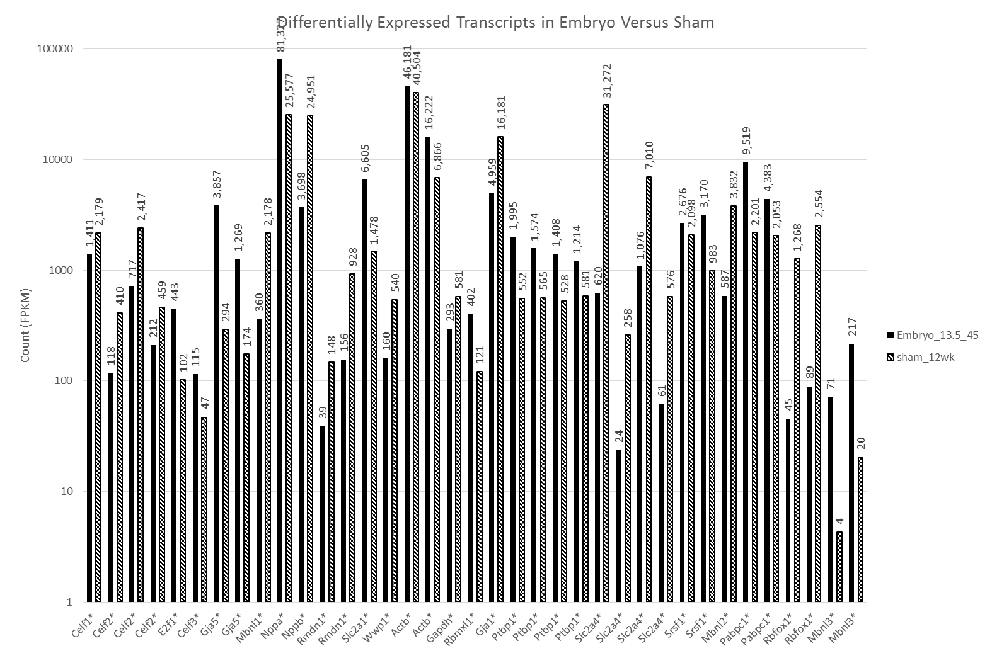

Figure 3 [Differentially expressed genes in study Embryo versus Sham Mice]

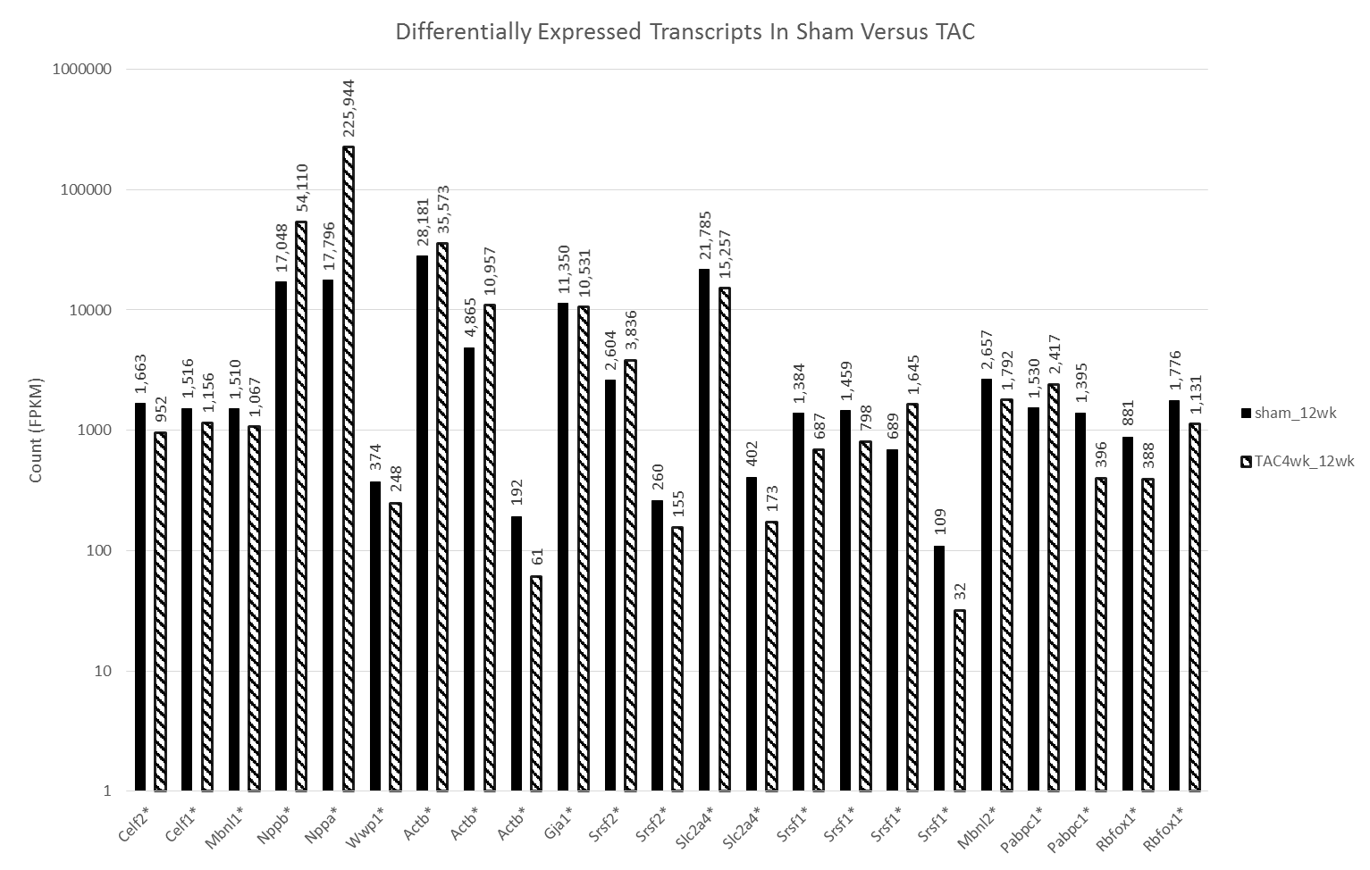

Figure 4 [Differentially expressed genes in study Sham versus TAC Mice]